**Austin Bike Sharing**

*Solving Austin’s Biggest Problem: TRAFFIC*

**Description**

We are incorporating the use of multiple datasets to determine ways in which Austin, Texas can improve the concept and practice of Bike Sharing. The datasets evaluated were: ‘Austin Bikeshare Stations’, ‘Austin Bikeshare Trips’, ‘Austin Weather’, and ‘Austin Traffic Count’.

The two main datasets- ‘Austin Bikeshare Stations’, and ‘Austin Bikeshare Trips’ is bikeshare data from 2013 to 2017 in Austin. We used these datasets to look for patterns and trends of the behavior of Austinites that take part in some form of bikeshare initiative. These datasets gave us an understanding for the type of consumers that Bike Share programs could benefit. For example, ‘Ride Duration’ and Type of Membership’ can tell us about the type of individual to use this transportation service.

The ‘Austin Weather’ dataset contains weather information from 2013 to 2017, which is the exact same time frame as our two main datasets. This was used to see if weather patterns play a role in how much bikeshare programs are utilized depending on changes in weather. Some data present in this dataset include: Temperature, Rain Predictions, and even Wind Speed.

The final piece of our data incorporates the use of demographic data in the city of Austin. To evaluate demographic data, we used the official website of the City of Austin to gather demographic information based on zip code. 1 Interesting findings could be derived when looking to see if any patterns or trends emerge where Bike Sharing programs perform well, and areas that not utilize this service at all. Some examples of this type of data include: Population Aged 15-24, how many people Walk to Work, and even whether or not that particular zip code is considered to be a Tourist location.

**Importance of the Problem**

The value of this problem comes from the fact that it seeks to find a potential solution to a problem that has been plaguing Austin for years and will only continue to get worse: Traffic. Transportation in Austin, TX is an issue that legislators have been trying to solve for years. Rather than approach this problem form a broad perspective, our group wanted to focus on a tangible and applicable solution that could be implemented rather seamlessly.

This problem is most certainly applicable to not only the broad audience of citizens of Travis County, but can also be extended to other large metropolitan areas that suffer from similar traffic congestion, such as: Los Angeles, New York City, Atlanta, and may more.

There are also broader benefits of a solution that extend beyond traffic. For example, encouraging bike sharing has enumerable health benefits for society, and encourages people to commute in a much more active and health-conscious manner.

We felt the need to do our due diligence and assess all possible factors that could potentially lead to insights. Incorporating the use of Membership data, Weather data, and even analyzing Demographics can all lead to potential solutions to the traffic problem.

We firmly believe that addressing Austin’s traffic problem is not only incredibly beneficial for citizens of Austin, but also has the potential to extend beyond to other large cities facing similar health and traffic concerns. Implementing a bike sharing solution that makes bike sharing convenient and efficient has the potential to make many people happy, and this is why we feel solving this problem is so important to solve.

**Exploratory Analysis**

***Location***

When evaluating our datasets, we decided to intuitively think of what we already knew about bike sharing programs. First and foremost, we were aware that bike stations obviously play an important role in any bike sharing programs. The locations of the bike stations are important because those are essentially the pre-destined beginning and ending locations of a bike ride. Furthermore, we were familiar with the concept of bike station imbalance. Essentially, this is the issue that arises when there are either too many or too little bikes at a particular bike stations that fails to meet demand or is an inefficient use of supply. When a bike station imbalance occurs, this drastically impacts the efficiency of the bike sharing programs and decreases the likelihood of people using the bikes.

With this baseline understanding in mind, we wanted to get a sense of how the market for bike riders in Austin has changed from 2013 to 2017. Much to our pleasant surprise, we found that there has been constant increase each year, and the trend appears as if the market size will only continue to grow.

With a better understanding of the type of individuals interested in using bike ride shares, we decided to transition our analysis to focus on characteristics of the bike stations. To do this, we wanted to identify the Top 10 stations in terms of quantity of ‘Start Trips’ on an annual basis. This would reveal to us the locations that were most active for beginning a bike ride and could help us get a sense of which areas of Austin were using these programs the most. When looking at the data, an interesting trend that was uncovered was how some locations were progressively becoming more commonly used from 2014 to 2016. 2 For example, the bike station location of “Riverside @ S. Lamar” was the 5th most popular station in 2014 and 2015, but jumped all the way to the 1st most popular station in 2016. On the other hand, the station location, “Convention Center / 4th St. @ MetroRail” was the 2nd most popular location in 2014. However, by 2015 the “Convention Center / 4th St. @ MetroRail” location became 7th, and by 2016, fell all the way to 9th. These trends are incredibly beneficial for gaining an understanding of trends of Austin bike share traffic and identifying areas that are becoming more popular year by year.

***Membership***

The next phase of getting an understanding of the Bike Sharing market was to see the type of riders that were utilizing this program the most frequently. To obtain this, we took a look at the maximum amount of rides from different type of memberships. An aspect of the Bike Share program is that you have the opportunity to sign up for membership to get better deals per ride. For example, you are given the opportunity to sign up for a membership called, ‘Local30’. This ‘Local30’ membership is a 1-month membership that gives you an unlimited number of trips lasting up to 60 minutes. The design of these memberships is to incentive commuters to sign up and get discounted rates. When evaluating this data, we discovered that the Walk-Up category was by far the most frequently used type of ride- accounting for roughly 60% of all rides.3 This revealed to us that the majority of riders simply used this service on an ad-hoc basis and did not necessarily pre-plan to utilize the Bike Share. The next most common type of rider fell into the ‘Local365’ category- roughly a quarter of people that ride these bikes have this membership. This is a year-long membership that actually give access to Bike Share services in cities besides solely Austin. It was interesting to see that the vast majority of people either rode the bike without membership or have subscribed to a year-long membership.

***Time***

To specifically try and identify patters in the data, we wanted to essentially do a test of seasonality. When plotting the number or rides on a weekly basis, we noticed definitive spikes in the data. Over a 3-year window, there were consistent spikes in two months in particular: mid-late March and mid-late October.4 Instantly, we attributed this to the two most popular annual events in Austin- SXSW and ACL. These two events have consistently produced enormous surges in demand. As a matter of fact, Austin B-Cycle has stated on their website that, “Austin’s bike share system surpassed previous overall use record from 2015. This year saw a nearly 50% increase in bike share usage compared to 2017 and set an overall system record for the festival at 23,526 trips.”5 It is clear that SXSW and ACL generate an influx of demand that Bike Shares must prepare for.

To continue the analysis of finding peaks in demand, we decided to see if the day of the week plays a significant role in influencing demand. When doing this, we saw that Saturdays and Sundays contributed to most of the weekly demand.6 This met our expectation because we were able to tie this back to some of the previous analysis we had conducted. If one recalls, we saw that the ‘Walk Up’ consumer accounted for roughly 60% of demand. It is highly likely that individuals on the weekends are more than likely non-membership riders that want to use the Bike Share program to explore Austin. Furthermore, the people that use Bike Share during the Weekday are likely to be subscribed members that use the service on a pre-meditated basis. Since we had determined previously that ACL and SXSW lead to spikes in usage, we wanted to see if this Weekend trend was also visible during those two events.7 As our intuition told us, we saw that there was in fact the same trend during ACL and SXSW. Weekend usage is consistently higher than during the Weekdays, and this is another factor that must be considered when attempting to plan for demand.

With the understanding that SXSW and ACL are essentially outliers, we wanted to remove these events from our data and see if doing so would impact our observations of increases in demand on the weekends.8 What we saw was that the weekends continue to be the two dominant days of demand for Bike Sharing in Austin.

To get even more specific in our time analysis, rather than just broadly look at days of the week, we wanted to see if the Time of Day played a major role.9 After doing our Time of Day analysis, a couple of interesting discoveries emerged: Weekdays and Weekends had a very similar trend and late afternoons attributed to the highest usage. To address the first discovery, it was rather surprising to see that both the Weekdays and the Weekends had similar patterns. More specifically, both had the maximum number of rides occur between 2:00pm and 4:00pm. This late afternoon time makes sense because it is likely that people are either riding a bike to lunch or perhaps even leaving work at the 4:00pm time. The other discovery was that the Membership plan of ‘Local365’ saw multiple peaks during the times of 9:00am, 12:00pm, and 4:00pm. Our intuition tells us that this could potentially be students commuting to school in the morning, leaving at noon to grab lunch, and then leaving school in the late afternoon after their 3:30pm class ends. This insight incorporated the use of our Membership data and our Weekends/Weekdays data and utilizing multiple analysis is helping us gain a grasp of understanding demand of Bike Share in Austin.

To dive even deeper into time analysis, we wanted to incorporate the seasonal demand we had analyzed- where we observed that ACL leads to a significant spike in demand. Because of the significant surplus of demand, a decision was made to isolate ACL and see if there were differences based on Time of Day.10 Interestingly, when looking at both ACL Weekends, we saw a shift in demand towards both the early hours of the day, as well as at night. Being familiar with the format of ACL Weekend, it makes sense that why there would be spikes both before and after the event. In the morning, around 11:00am, people are making their way to Zilker Park. Then, after the final artist performs, people leave Zilker Park around the 10:00pm/11:00pm timeframe.

***Weather***

With a solid foundation established of a variety of factors, including: Location, Membership, and Time, we now felt it was appropriate to incorporate weather into the exploratory analysis. Clearly, Bike Share programs are heavily dependent on weather because of the nature of the activity, and we wanted to see how significant of a role weather played in influencing Bike Share patterns and trends. The most obvious intuition about the impact of weather is the influence rain has on Bike Share activity. However, much to our surprise, there was a relatively mild 67% drop in rides during rainy days. Apparently, 1 in 3 people do not mind the rain and will continue to utilize this service. The next weather-related trend we wanted to analyze was to see what happens on especially hot and cold days. During a ‘Hot Day’, which we classified as greater than 80˚Farenheit, there was a 36% drop in rides. On an especially ‘Cold Day’, which we considered to be less than 60˚Farenheit, there was a significant 72% drop in usage. When thinking about this analysis, we attributed this difference in Hot vs. Cold to be related to what citizens of Austin are used to. In general, people that live in Austin do not mind the heat because they have become accustomed to it. However, in the cold, Austinites prefer not to be riding bikes outside.

To tie in our Location analysis with the insights from weather, we wanted to see how some of the most popular locations were impacted by Rain, Heat, and Cold temperatures.

***Demographic***

The final broad category to perform exploratory analysis on is Demographic data that is broken down by zip code in Austin.

**Solution and Insights**

**References**

1. *“To evaluate demographic data, we used the official website of the City of Austin to gather demographic information based on zip code.1”*

<http://www.austintexas.gov/page/demographic-data>

1. *“When looking at the data, an interesting trend that was uncovered was how some locations were progressively becoming more commonly used from 2014 to 2016. 2”*

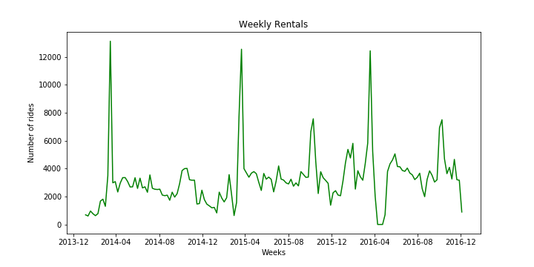

1. *“When evaluating this data, we discovered that the Walk-Up category was by far the most frequently used type of ride- accounting for roughly 60% of all rides. 3”*

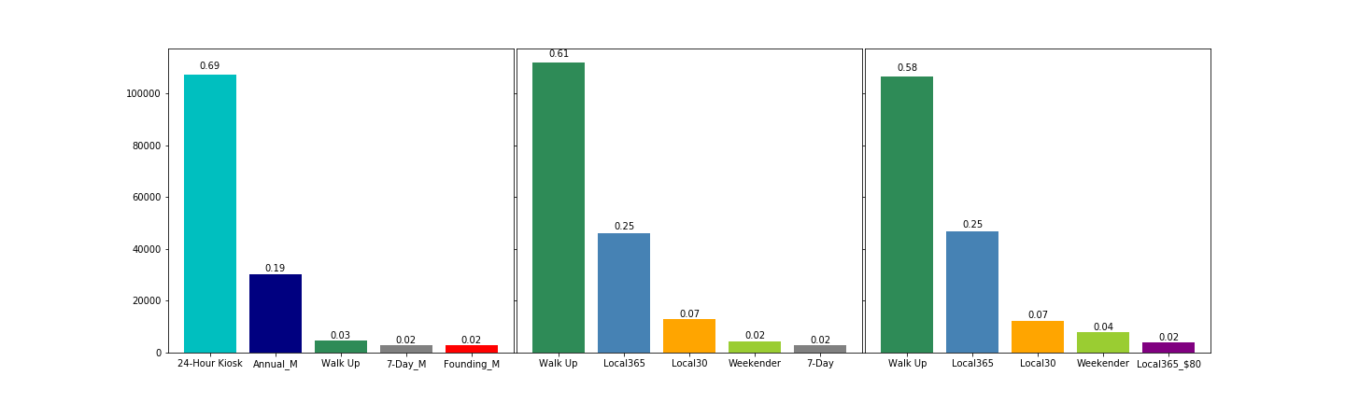

1. *“Over a 3-year window, there were consistent spikes in two months in particular: mid-late March and mid-late October.4”*



1. *“Austin’s bike share system surpassed previous overall use record from 2015. This year saw a nearly 50% increase in bike share usage compared to 2017 and set an overall system record for the festival at 23,526 trips.5”*

<https://austinbcycle.com/about/blog/another-successful-year-for-austin-b-cycle-x-sxsw>

1. *“When doing this, we saw that Saturdays and Sundays contributed to most of the weekly demand.6”*

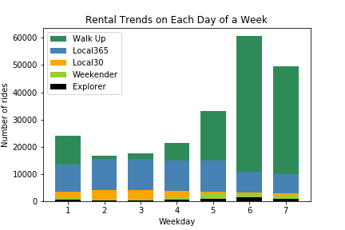

1. *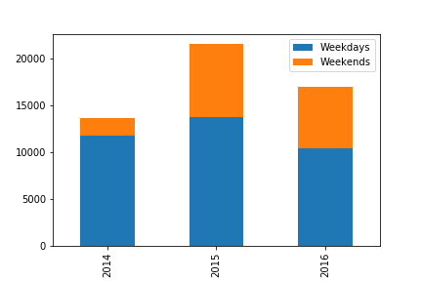“Since we had determined previously that ACL and SXSW lead to spikes in usage, we wanted to see if this Weekend trend was also visible during those two events.7”*

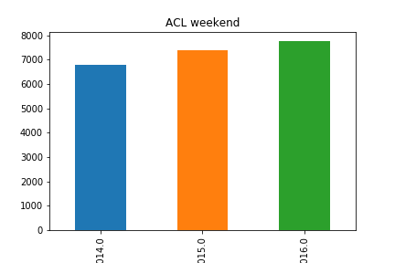

1. *“With the understanding that SXSW and ACL are essentially outliers, we wanted to remove these events from our data and see if doing so would impact our observations of increases in demand on the weekends.8”*

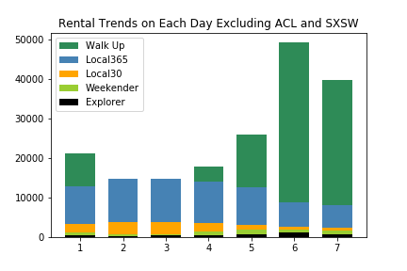

1. *“To get even more specific in our time analysis, rather than just broadly look at days of the week, we wanted to see if the Time of Day played a major role.9”*

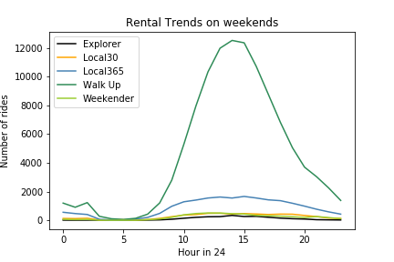 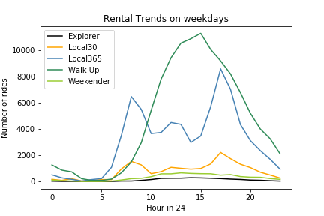

1. *“Because of the significant surplus of demand, a decision was made to isolate ACL and see if there were differences based on Time of Day.10”*

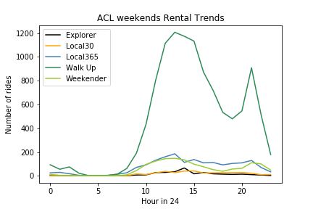11.